LAB - 5

Implementation of IF statement using shell script

H - left
J - down
K - right
L - up
Delete line - double d

Ctrl + i = insert mode
Ctrl + a == append mode
Special line = #! (it is special line)
Comment = #

Command :
Vi filename.sh
Chmod +x filename.sh
Run file = ./filename.sh

if [ condition ]
then

-eq -ne -lt -gt

Echo = right text on command
read= for reading data
Use esc for every termination of all

For saving file : esc + shift ; + wq + enter
For running file : ./filename.sh

Part: A

Write a Shell Script:

1. Which works like a calculator and performs below operations Addition, Subtract, Division and Multiplication.

#!bin/bash
#1. Which works like a calculator and performs below operations Addition, Subtract, Division and Multiplication.
# display menu
echo "Select operation : "
echo "1 . Addition "
echo "2. substraction"
echo "3. multiplication"
echo "4. division"

#take use input
read -p "enter your choice from 1 to 4 : " choice
read -p "enter first number : " n1
read -p "enter second number : " n2

if [ $choice -eq 1 ]; then
result=$((n1 + n2 ))
echo "sum is : $result"
fi

if [ $choice -eq 2 ]; then
result=$((n1 - n2 ))
echo "substraction is : $result"
fi

if [ $choice -eq 4 ]; then
result=$((n1 * n2 ))
echo "multiplicaion is : $result"
fi

if [ $choice -eq 4 ]; then
result=$((n1 / n2 ))
echo "division is : $result"
fi

2. To find a largest number from 2 numbers.

#!/bin/bash
# Lab 5-2 : To find a largest number from 2 numbers................
# Take two numbers as default
read -p "Enter the first number : " num1
read -p "Enter the second number: " num2

# Compare the numbers using only if conditions
if [ $num1 -gt $num2 ] ; then
echo "The largest number is : $num1"
fi

if [ $num2 -gt $num1 ]; then
echo "the largest number is : $num2"
fi

if [ $num1 -eq $num2 ]; then
echo "Both numbers are equal : $num1"
fi

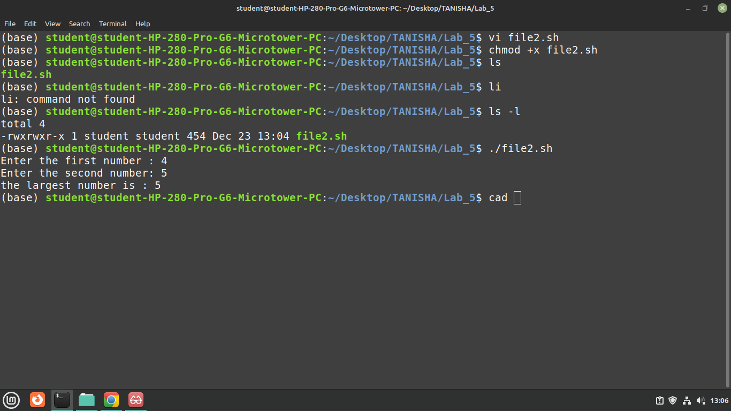

3. To check whether given no is ODD or EVEN.

#!/bin/bash
# Lab 5 - 3
# To check whether given no is ODD or EVEN.
# taking one number
read -p "Enter the first number : " num1

if [ $((num1 % 2)) -eq 0 ]; then
echo "The number $num1 is EVEN"
fi

if [ $((num1 % 2)) -ne 0 ]; then
echo "The number $num1 is ODD "
fi

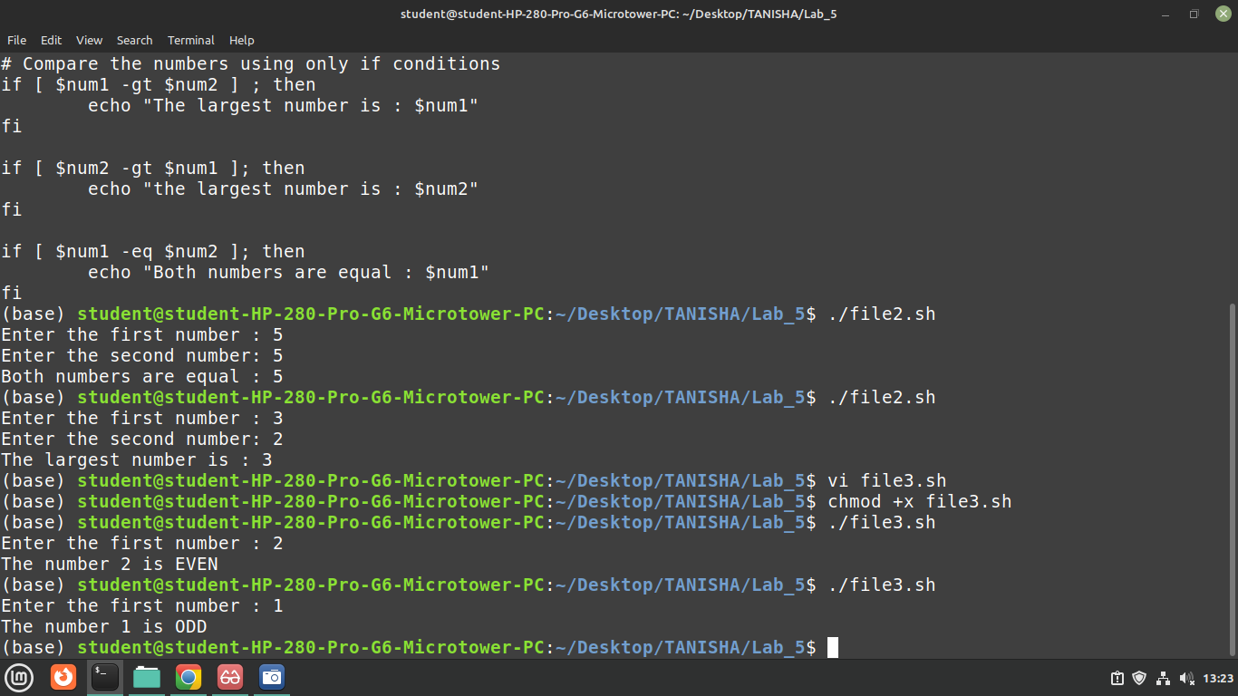

Part: B

Write a Shell Script:

1. To check whether given no is NEGATIVE or POSITIVE.

2. To check whether given no is divisible by 5 or not.

3. To check whether person is eligible to vote. (age>18)

Part: C

Write a Shell Script:

1. To check whether a given year is leap year or not.

2. To accept two integers and check whether they are equal or not.

3. To check if a triangle is valid based on side lengths. (Sum of two sides are greater than third side)

